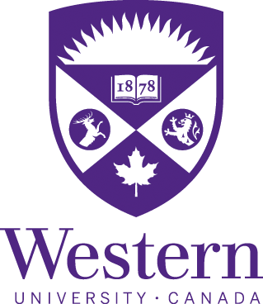

Welcome to Western University! Below you will find a few links to our website - including our future student mailing list and contact information for your student recruitment officer.

Check us out, get to know us a bit better, and let’s see if you Choose Western!

Check out our publications

Go on a virtual tour of campus

Participate in our virtual events

Join our mailing list

Contact your recruiter Lauren Castle

